

Rip City Project

Group : 3

Names : Casey Khaled Arozal

Tubagus Muhammad Fauzi Irfani

Class : 4SC3

Faculty : Mr. Fachran Nazarullah

CEP CCIT

FAKULTAS TEKNIK UNIVERSITAS INDONESIA

2020



**Developed By**

1. **Casey Khaled Arozal (1820010049)**
2. **Tubagus Muhammad Fauzi Irfani (1820010210)**

**PROJECT ON**

*Rip City Project*

Batch Code : 4SC3

Start Date : 27th June 2020

End Date : 2nd July 2020

Name of Faculty : Mr. Fachran Nazarullah

Name of Developer :

1. Casey Khaled Arozal (1820010049)
2. Tubagus Muhammad Fauzi Irfani (1820010210)

Date of Submission : 3rd June 2020

**Rip City Project**



**CERTIFICATE**

This is to certify that this report titled “Rip City Project” embodies the original work done by Casey Khaled, and Tubagus Muhammad. Project in partial fulfillment of their course requirement at NIIT.

Coordinator :

Mr. Fachran Nazarullah

**ACKNOWLEDGEMENT**

With the name of God, The Most Gracious Most Merciful, we a praise over his presence, which has been part of his grace, so that project about Rip City Project can be completed which God willing useful for all of us.

Project report has been in rows with its fullest and got help from various parties and the source so that it can facilitate the creation of this report. And especially to Mr. Fachran Nazarullah . Who has provided guidance in making these Project report.

Bekasi/Jakarta, 23 th July 2020

Writer

**SYSTEM ANALYSIS**

**System Summary :**

This is an application called Rip City Project, this app basically is the app for American Basketball Team called Portland Trailblazers, this app contains all the information about Portland Trailblazers, like the history, latest roster, jersey, home court, and game schedule. We use Android Studio, and Firebase Realtime Database in the making.

**INTRODUCTION**

In this project, we will provide schedule for upcoming match. This table connect to firebase database so we can add, update and delete. Also in thisapplication, we provide authentication for admin that log in into admin page using email authentication.

**ACTIVITY LIST**

|  |  |  |  |  |  |
| --- | --- | --- | --- | --- | --- |
| S.NO | Activity Description | Planned Date of Completion | Actual Date | Responsibility | Remarks |
| 1 | Create Home Page Design | 22nd July 2020 | 22nd July 2020 | Tubagus Muhammad |  |
| 2 | Create Roster Page Design | 22nd July 2020 | 22nd July 2020 | Tubagus Muhammad |  |
| 3 | Create Schedule Page Design | 22nd July 2020 | 22nd July 2020 | Tubagus Muhammad |  |
| 4 | Create Admin Login Page | 22nd July 2020 | 22nd July 2020 | Casey Khaled |  |
| 5 | Connecting the app into the web with Firebase | 22nd July 2020 | 22nd July 2020 | Casey Khaled |  |
| 6 | Impementing Email Auth in Admin Login Page | 22nd July 2020 | 22nd July 2020 | Casey Khaled |  |

**DESIGN OF APPS**

This is Home Page

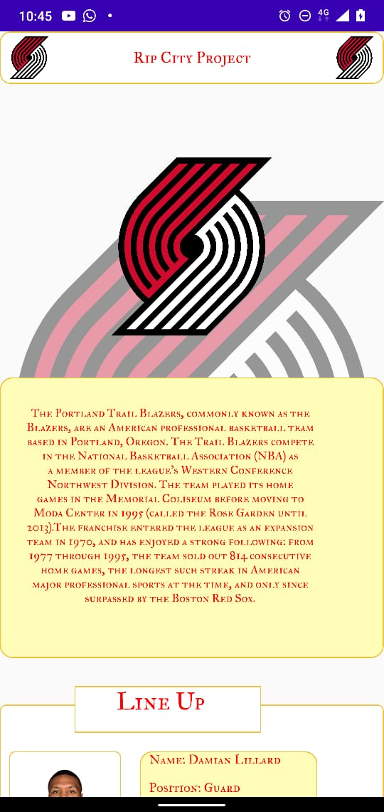 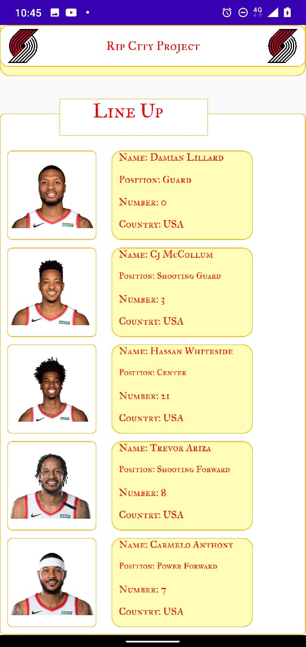

**DESIGN OF APPS**

This is Roster and Schedule Page

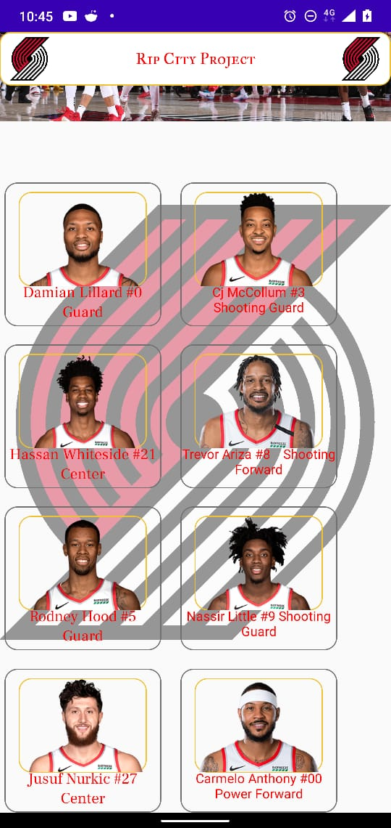 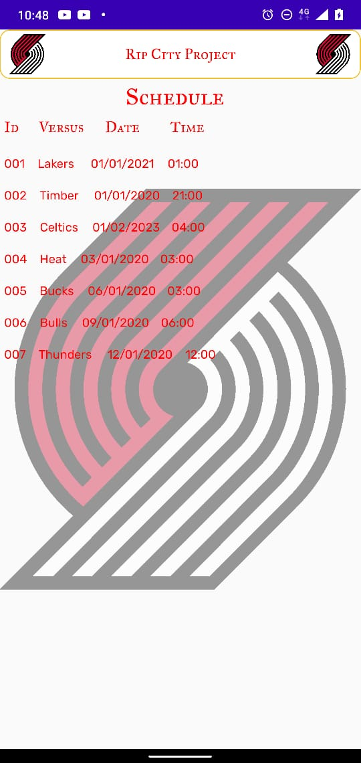

This is Login Admin Page

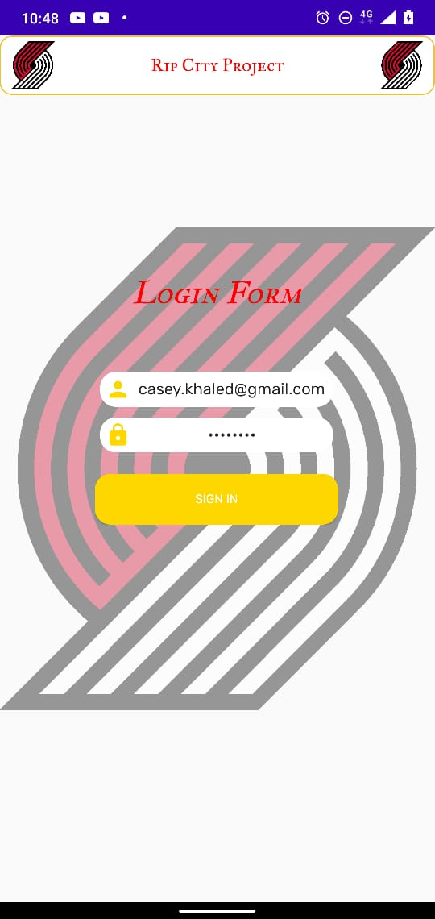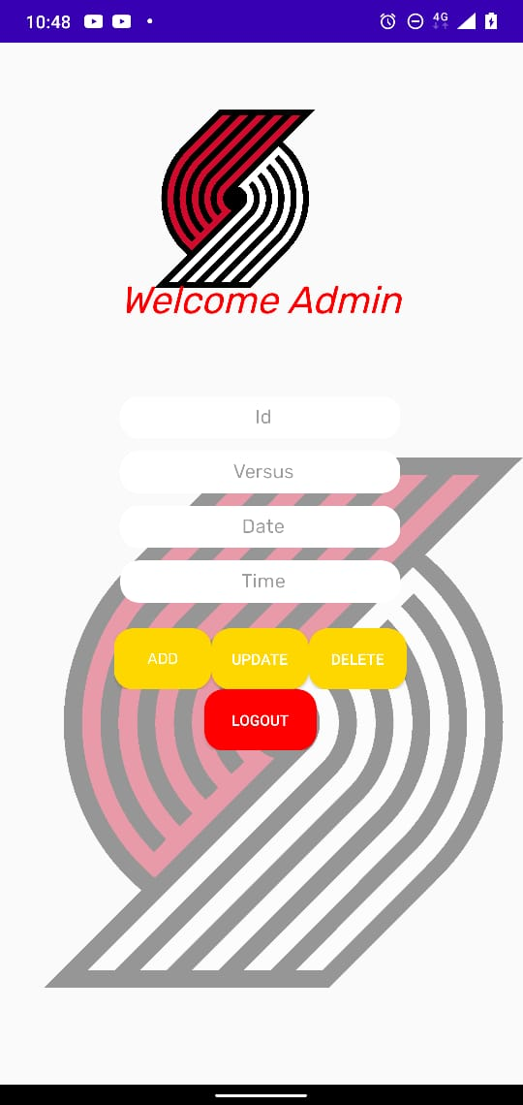

**DESIGN OF APPS**

This is design in Admin Login Page and Admin Page.

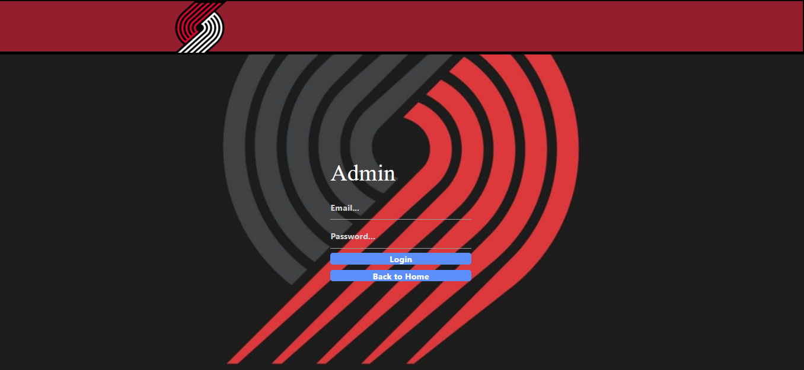 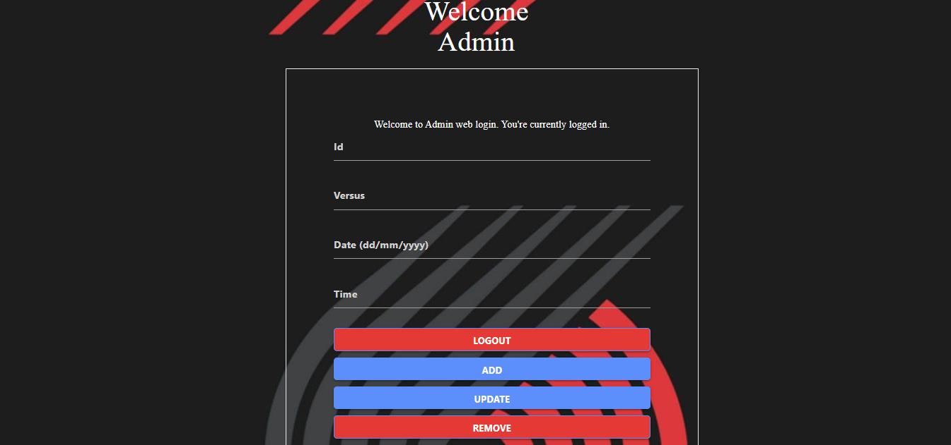

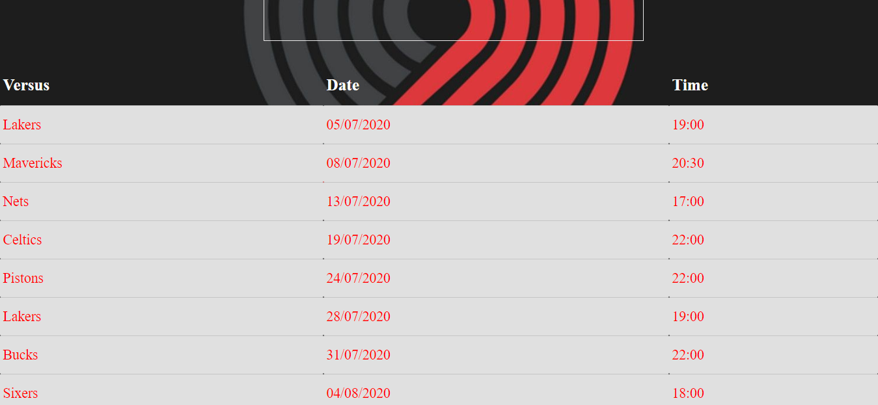

**IMPLEMENTATION**

In All Page:

* We are using JavaScript and Firebase to Connect Schedule Table.
* We are using Google App Engine to Deploy our Project.

In Admin Login Page

* We are using Email Firebase Authentication for Login.

**PREVIEW OF APPS**

Web Preview using Screenshot:

Home Page

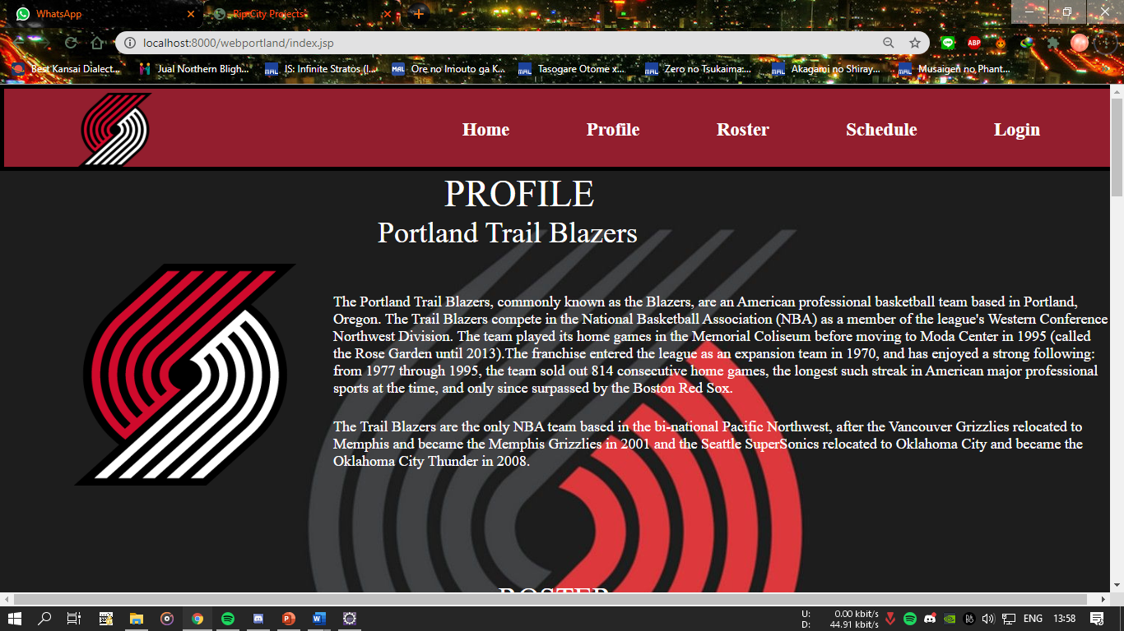

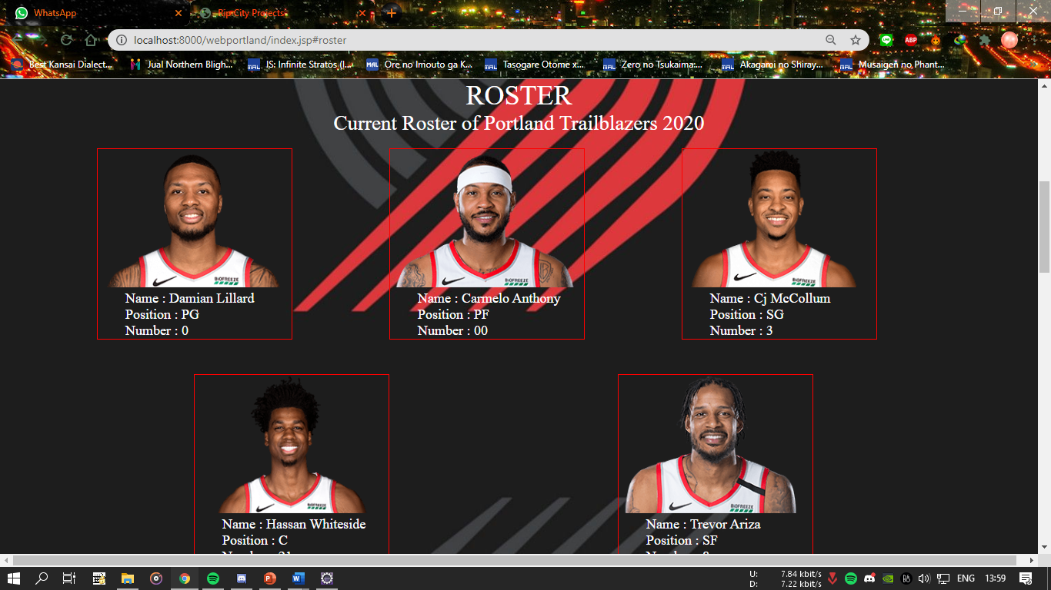

**PREVIEW OF WEB**

Web Preview using Screenshot:

Home Page

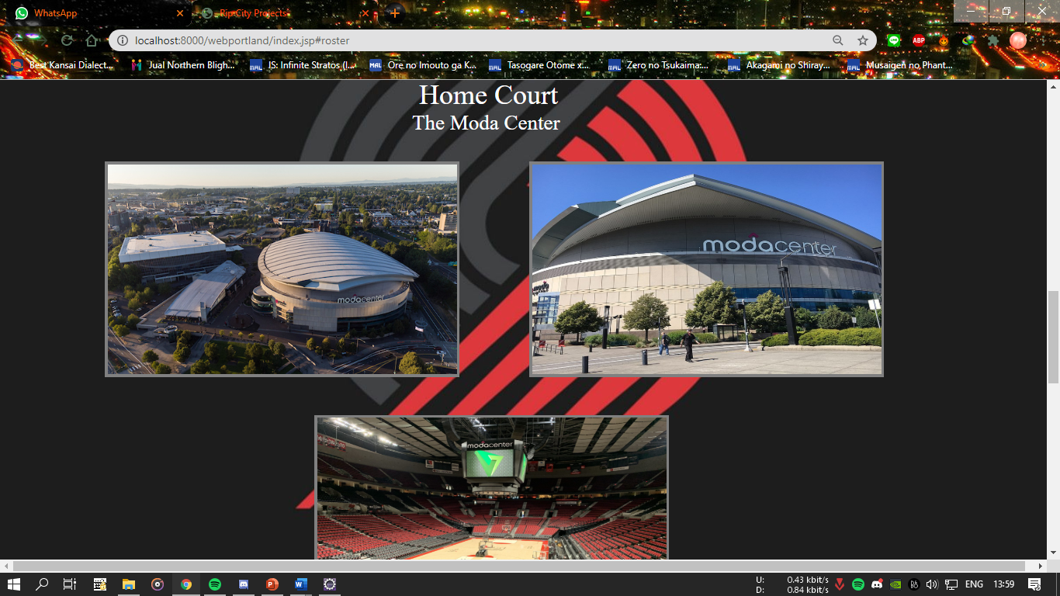

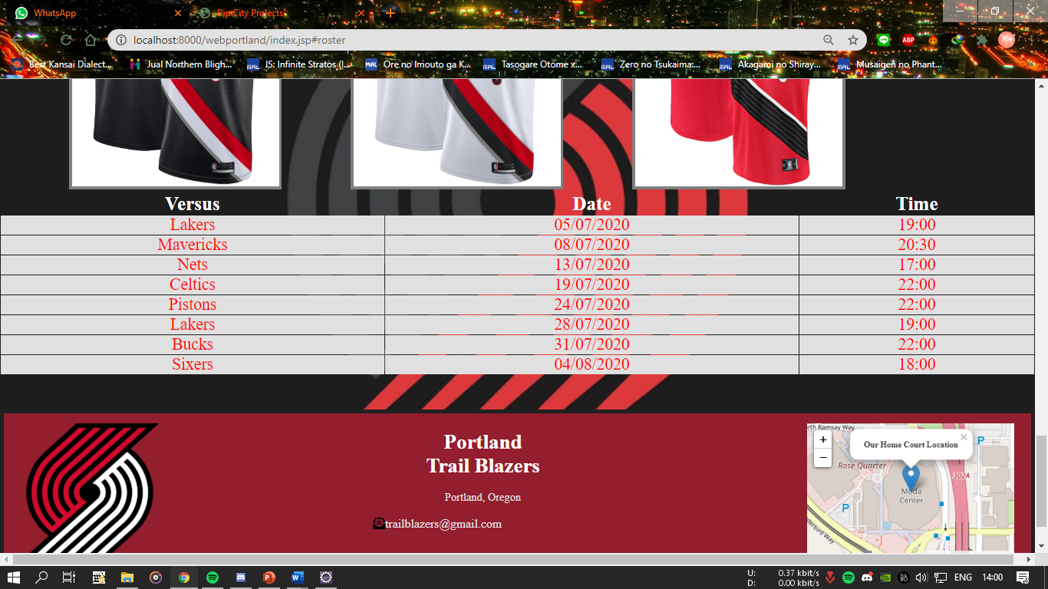

**PREVIEW OF WEB**

Web Preview using Screenshot:

Admin Login Page.

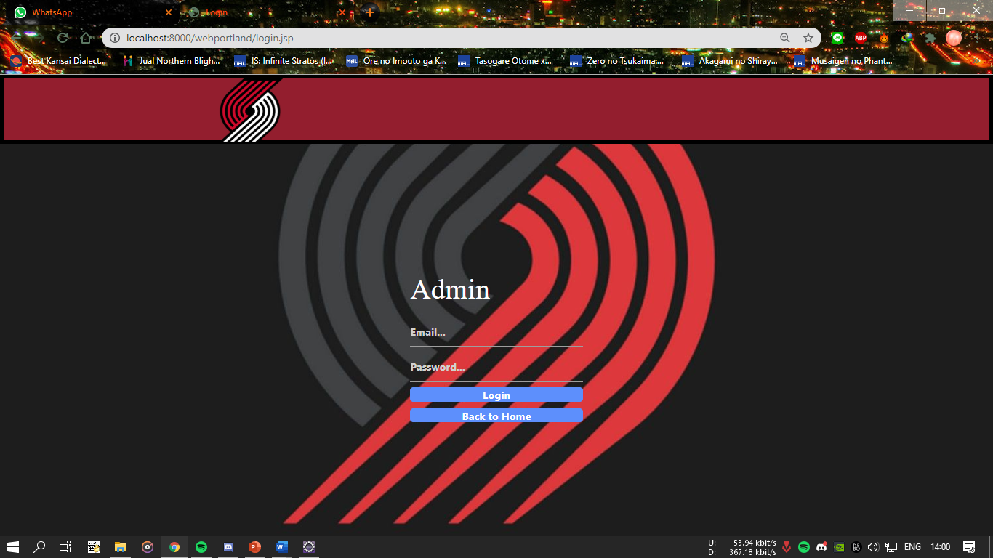

**PREVIEW OF WEB**

Web Preview using Screenshot:

Admin Page.

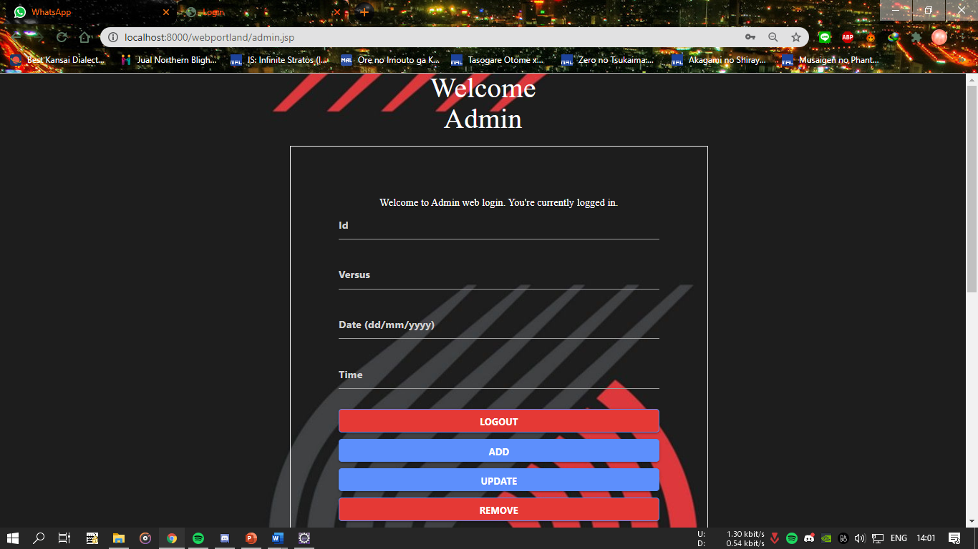

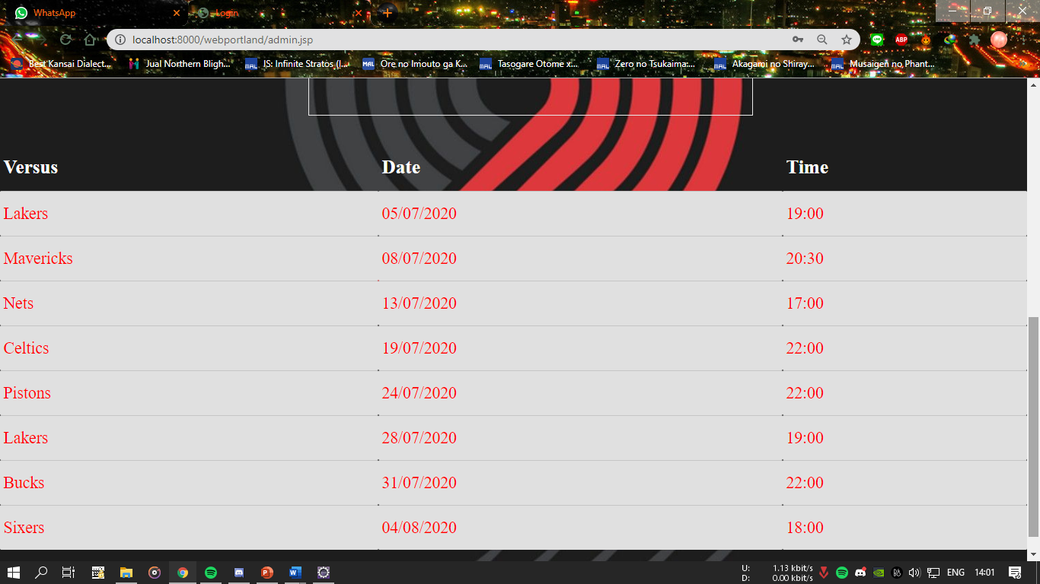

**BLACKBOX TESTING**

|  |  |  |  |  |  |
| --- | --- | --- | --- | --- | --- |
| **No** | **Scenario** | **Test Data** | **Expected Result** | **Actual Result** | **Output Result (PASS/FAIL)** |
| 1 | Admin Login | Valid | Login success and admin redirected to admin page | Login success and admin redirected to admin page | PASS |
| 2 | Admin Login | Invalid | Prompt Login failed and admin stay in login form | Prompt Login failed and admin stay in login form | PASS |
| 3 | Admin Add New Data | Valid | Add success and data will store to firebase and will show in populations page | Add success and data will store to firebase and will show in populations page | PASS |
| 4 | Admin Add New Data | Invalid | Add failed and data does not store to firebase and can’t show in populations page | Add failed and data does not store to firebase and can’t show in populations page | PASS |
| 5 | Admin Update Data | Valid | Update success and data will update in firebase and will show in populations page | Update success and data will update in firebase and will show in populations page | PASS |
| 6 | Admin Update Data | Invalid | Update failed and data doesn’t change in firebase and in populations page | Update failed and data doesn’t change in firebase and in populations page | PASS |

**BLACKBOX TESTING**

|  |  |  |  |  |  |
| --- | --- | --- | --- | --- | --- |
| **No** | **Scenario** | **Test  Data** | **Expected Result** | **Actual Result** | **Output Result (PASS/FAIL)** |
| 7 | Admin Deleted Data | Valid | Delete success and data will deleted in firebase and the populations page | Delete success and data will deleted in firebase and the populations page | PASS |
| 8 | Admin Deleted Data | Invalid | Delete failed and data still in the firebase and the populations page | Delete failed and data still in the firebase and the populations page | PASS |
| 9 | Admin Logout | Valid | Logout success and admin redirected to home page | Logout success and admin redirected to home page | PASS |
| 10 | Admin Logout | Invalid | Prompt Logout failed and admin stay in admin page | Prompt Logout failed and admin stay in admin page | PASS |

**Hardware : *Intel(R) Core(TM) i7-5500U CPU @ 2.40GHz (4 CPUs), ~2.4GHz, HP***

**Operating System : *Windows 10 Ultimate***

**Software :Android Studio,**  ***and Eclipse IDE.***

**PROJECT FILE DETAILS**

|  |  |  |
| --- | --- | --- |
| **S.No** | **File Name** | **Remarks** |
| **1** | LoginAdmin.java | Java page that contains code for admin to log in. |
| **2** | MainActivity.java | Java page that contains the code of the main activity. |
| **3** | UserHelperClass.java | Java page that contains setter getter variables for the schedules. |
| **4** | activity_main.xml | XML page that contains the main layout. |
| **5** | admin_page.xml | XML page that contains the crud for admin. |
| **6** | fragment_slideshow.xml | XML page that contains the email auth for admin. |
| **7** | user_list_item.xml | XML page that contains the Schedules lists. |

**CONFIGURATION**